WYD DON BOSCO 23
WYD DON BOSCO 23 is the name of the organization of the Salesian Youth Movement responsible for the convocation and participation of young people from various Salesian environments around the world in WYD Lisbon 2023, living it according to the charism of Don Bosco. WYD DON BOSCO 23 wants to motivate young people to walk this path as a pilgrimage that strengthens their faith and challenges others, who are further away, to know the Living Christ.
WYD DON BOSCO 23 comes from the combination of the acronym in English which refers to World Youth Day; Don Bosco, as the Salesian Family aggregator; and the date of the meeting.

Materials and advertising
- www.wyddonbosco23.pt
Website (PT and EN version) where you can find various information about Portugal, Lisbon, WYD and the organization WYD DON BOSCO 23. It will be regularly updated with new information and news.
- https://youtu.be/BXBhtMwjdIY
Promotional Video The WYD DON BOSCO 23 has prepared a video presentation of the participation of the Salesian Youth Movement in the WYD Lisbon 2023.
Thought, recorded and starred by students and former students from different Salesian environments in Portugal, this video appeals to the participation of the members of the SYM from around the world in this meeting and invites them to live it according to the charism of Don Bosco.
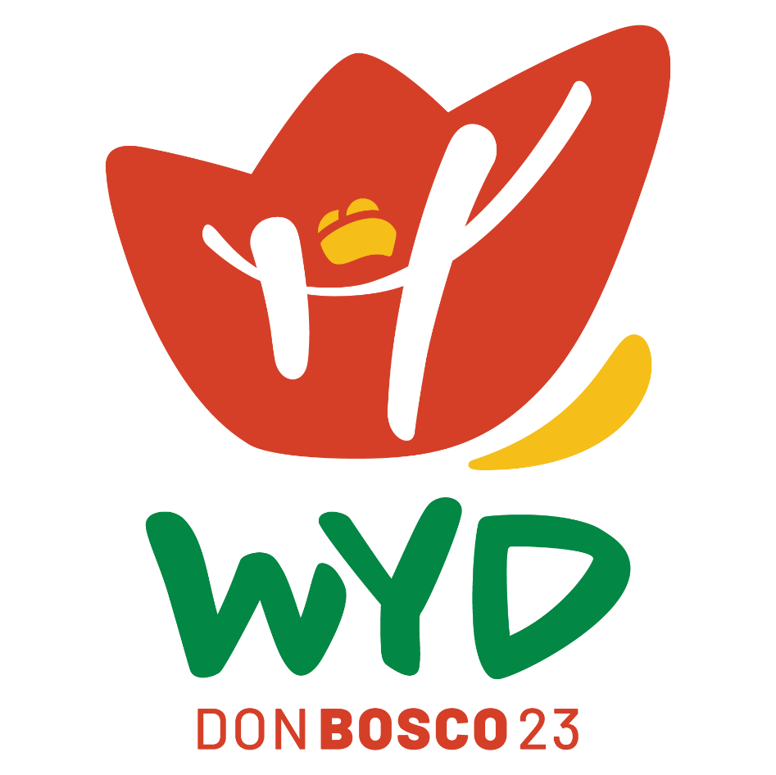
The video tells the story of five friends of different nationalities who, after exchanging some messages, agree to meet in Portugal to participate in WYD Lisbon 2023 and, at the same time, in WYD DON BOSCO 23.

The logo of WYD Don Bosco 23 was inspired by the figures of Don Bosco and Mary Help of Christians. The basis of the whole logo is the mantle of Mary that appears to "embrace" all the other elements. Inside the mantle we find the tricorn of Don Bosco; as well as two crosses, symbols of our faith. There is also a rope that reminds us of jumping jacks, an allusion to the fact that Don Bosco used games and juggling as a way to captivate young people and bring them into the Church, winning their hearts.
The yellow band, which appears on the right side of the logo, suggests an upward movement, inviting us to get up and go, and which leads us to the motto of WYD Lisbon 2023.
- https://www.facebook.com/wyddonbosco23
Facebook profile WYD DON BOSCO 23
- https://www.instagram.com/wyddonbosco23/
Instagram profile WYD DON BOSCO 23
- https://www.youtube.com/channel/UCNHL0RbvRX3AwyGSIj1tSMw
YouTube Channel WYD DON BOSCO 23
- https://wyddonbosco23.pt/jmj-combosco/
A weekly podcast that has conversation, information, music and testimonies and is on the way to the World Youth Day 2023 in Lisbon. [only available in Portuguese]
It will address the various editions of WYD from 1986 to the present day, focusing on the messages, main events, incredible stories, giving the word to those who participated in them or who are currently, in some way, in the organization of WYD Lisbon 2023. It also makes reference to the history and growth of the SYM as a youth movement that has been growing stronger over the past three decades.

Some information about WYD Lisbon 2023:
WYD will take place in the city of Lisbon between 1st and 6th of August, 2023.
It is anticipated that registration for WYD Lisbon 2023 will open next summer. We ask you to wait for our indications so that we can all register as a SYM group.
We can already tell you that the Macro SYM group will be housed in Salesian houses in the Lisbon area, as well as in families related to our houses during WYD.
We are also preparing a big party for SYM Day, to be held on August 2nd. As usual, the forum, sports tournaments, an afternoon of oratorian festivities and the prayer vigil will be attended by everyone.
There will also be the possibility of a visit to Fatima organized by WYD DON BOSCO 23 on August 7th for the groups that want to sign up.
Regarding the pre-WYD, it is also possible to hold them in Portugal the week before WYD.
In the coming weeks we will send more information.

We are counting on everyone in Lisbon!

If you have any questions, suggestions or if you simply want to know more about WYD Lisbon 2023 and WYD DON BOSCO 23 please contact: wyddonbosco23@staff.salesianos.pt

